
HASS  Australia in a diverse world | Year 6 | Unit 3
Assessment task — Australia in a diverse world: Model response
Part A: Identifying and representing characteristics of places
Use the Assessment task — Australia in a diverse world: Sources to complete Part A.
Estimate (to the nearest full degree) the latitude or longitude for each of the cities listed in the table. Use Source 1.
Place | Latitude | Longitude
Brisbane, Australia | 27°S | 153°E
Kuala Lumpur, Malaysia | 3°N | 102°E
Mogadishu, Somalia | 2°N | 45°E
New York, USA | 41°N | 74°W
Manila, Philippines | 15°N | 121°E
Mumbai, India | 19°N | 73°E
Locate the following cities on the world map (Source 1). Record the names of each city at the correct location on the map.
Place | Latitude | Longitude
Darwin, Australia | 12°S | 131°E
Jakarta, Indonesia | 6°N | 107°E
London, England | 52°N | 0°
Tokyo, Japan | 36°N | 140°E
Athens, Greece | 38°N | 24°E
Rio de Janeiro, Brazil | 23°S | 43°W

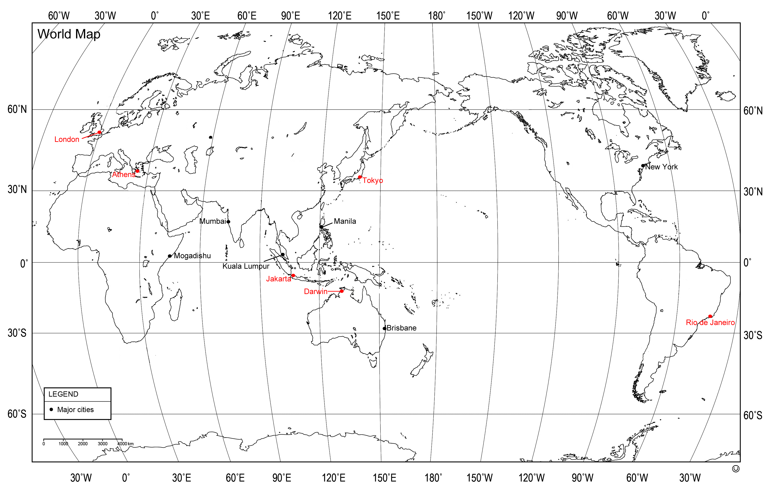
Use Source 2 when responding to Q 3–7.
Identify the category of GNI for each country listed in the table.
Table: GNI per capita of selected countries of East Asia 2015
Country | GNI per capita (US$) | Category of GNI
China | $7 820 | Upper Middle Income
Japan | $36 680 | High Income
Malaysia | $10 570 | Upper Middle Income
Vietnam | $1 980 | Lower Middle Income
Cambodia | $1 070 | Lower Middle Income
Philippines | $3 540 | Lower Middle Income
Data sourced from: The World Bank, GNI per capita, Atlas method (current US$) http://data.worldbank.org/indicator/NY.GNP.PCAP.CD?locations=CN&view=map
- Represent the category of GNI for these countries on the map. Tick () the countries as you record them on the map.
- China | - Malaysia | - Cambodia
- Japan | - Vietnam | - Philippines
Sample map from Source 2.
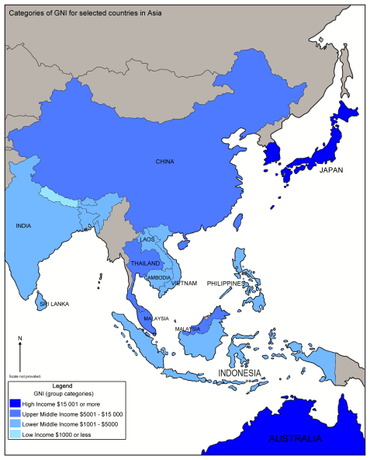
- Describe the distribution of High Income countries represented on the map — consider the terms clustered, linear and dispersed. Answers will vary.
The distribution of High Income countries is clustered in the north-east Asia region. It could also be said that the distribution is dispersed due to the location of Australia — the third High Income country — in relation to Japan and South Korea.
- Describe the distribution of Lower Middle Income countries represented on the map — consider the terms clustered, linear and dispersed. Answers will vary.
The distribution of Lower Middle Income countries can be described as linear. Countries throughout west, south and South-East Asia are classified as Lower Middle Income. The distribution could also be described as clustered in west Asia, and clustered in South-East Asia.
- How does Australia’s GNI compare to countries in Asia? Answers will vary.
Australia’s GNI is much greater than most countries in Asia. Australia falls in the High Income category, whereas most Asian countries fall in the Lower Middle Income category.
Use Sources 3 to 5 when responding to Q 8–11.
- Identify and describe the trends represented by the Annual Population Growth data for Australia and Indonesia between 2012 and 2015.
Answers will vary. The data for both countries show a downward trend in Annual Population Growth between 2012 and 2015.
- Describe the average life expectancy of people in Australia compared to Indonesia.
Answers will vary. The average life expectancy of people in Australia is greater than that of people living in Indonesia.
- Identify a characteristic from the table that impacts on life expectancy.
Answers will vary. Percentage of population with access to improved drinking water would impact on life expectancy.
- Explain how this characteristic impacts on life expectancy in Indonesia.
Answers will vary. People can become sick and can even die from drinking polluted water. If there is a percentage of people in a country, for example, Indonesia, that cannot access clean water, then this would have an impact on the average life expectancy of the population in that country.
Part B: Describing the diversity of places
Use the Assessment task — Australia in a diverse world: Sources to complete Part B.
Note: Aboriginal peoples and Torres Strait Islander peoples are warned that this resource may contain images and names of persons who may now be deceased.
Use Source 6 when responding to Q 1–5.
- Identify and describe an environmental characteristic of Australia and Japan that is similar.
Answers will vary. Parts of Japan and Australia have tropical climates. Parts of Japan and Australia experience dangerous natural hazards such as severe storms (typhoons, cyclones).
- Identify and describe an environmental characteristic of Australia and Japan that is different.
Answers will vary. Most of the land in Japan is rugged and mountainous. In contrast, Australia has desert areas and fertile plains. The land area of Australia is much larger than the land area of Japan.
- Identify and describe a social characteristic of Australia and Japan that is different.
Answers will vary.In Australia, most people speak English, whereas in Japan, the main language spoken is Japanese.
- Explain how economic characteristics (human activities) influence environmental characteristics in Australia and Japan.
Answers will vary. In Australia, shipping and tourism has impacted negatively on the Great Barrier Reef. In Japan, pollution from power plants has resulted in acid rain.
- Draw a final conclusion about how the characteristics of Australia and Japan are diverse.
Answers will vary. Although both countries are island nations, Australia and Japan are diverse in many ways. In terms of land area, Australia is much larger than Japan. However, Japan has a much larger population than Australia. This means that in Japan, more people have less space to live. Although Australia and Japan experience natural hazards, the types of hazards differ between countries. Parts of Australia experience severe droughts, floods and fires, whereas parts of Japan experience earthquakes and tsunamis. Social or cultural characteristics also illustrate the diversity of these countries. The main religions of Australia are of European origin, whereas the main religions of Japan are distinctly Asian in origin. Most people in Australia speak English, whereas most people in Japan speak Japanese.
Use Sources 7 and 8 when responding to Q 6–8.
Summarise the natural (environmental) and human (cultural) characteristics of the Dayak peoples (Borneo) and the Yolngu people (Arnhem Land).
 | Dayak peoples | Yolngu people
Natural characteristics | - live in tropical, equatorial region of Borneo (South-east Asia)  - jungles, hard (difficult) terrain  - average monthly temp. is between 25°c and 30°c | - live in North-east Arnhem Land (Northern Territory)  - coastal and bush environments  - average monthly temp. is between 24°c and 29°c
Human characteristics | - many ethnic groups  - 140 different languages and dialects  - good hunters/trackers  - traditional, communal long houses (made from rainforest timber)  - practise beadwork/make ceramic jars  - dance and ceremony is important | - speak different dialects of language called ‘Yolngu Matha’  - ‘yidaki’ is a didgeridoo made by Yolngu people in eastern Arnhem Land  - weave pandanus leaves to make baskets  - make necklaces from natural materials e.g. seeds and shells  - hunt bush animals, sea animals and collect seasonal bush foods

- Identify and describe similarities between the natural and human characteristics of the Dayak peoples and the Yolngu people.
Answers will vary. The Dayak peoples and the Yolngu people live in places that experience consistent average monthly temperatures that range between 24°c and 30°c. Both groups practise artwork in various forms, using materials from their natural environments.
- Identify and describe differences between the natural and human characteristics of the Dayak peoples and the Yolngu people.
Answers will vary. The Dayak peoples live in places that contain difficult, jungle terrain, whereas the Yolngu people live and hunt in coastal areas. The Dayak peoples speak 140 different languages and dialects. The Yolngu people speak different dialects of a language they call ‘Yolngu Matha’.
- Explain the relationship between the environmental characteristics and the human characteristics of one Indigenous group — consider how diverse characteristics influence and are influenced.
Answers will vary. The human characteristics that are present in the home places of the Yolngu people have been influenced by environmental characteristics. Yolngu people use materials from the natural environment to create their art, for example, woven pandanus baskets and necklaces made from shells and seeds. The diets of the Yolngu people are also influenced by the types of food that can be caught / gathered during different seasons. They rely on the ocean for supplies of seafood, such as fish and oysters.

